**Lab 6: Android Send Email**

# **Introduction**

Instead of creating an email client from start in Android, we can easily send an email from our application using pre-existing email clients like GMAIL, Outlook, etc. For the most part, the Android Intent object with the correct action (ACTION_SEND) and data will assist us in launching the accessible email clients so that we can send emails from within our application.

**Let’s get Started:**

In this Exercise we will be implementing  to send Email.

**Step 1**: open an **activity_main.xml** file from **\res\layout** path and write the code like as shown below.

**activity_main.xml**

*<?*xml version="1.0" encoding="utf-8"*?>*<LinearLayout xmlns:android="http://schemas.android.com/apk/res/android"  
 xmlns:tools="http://schemas.android.com/tools"  
 android:layout_width="match_parent"  
 android:layout_height="match_parent"  
 android:orientation="vertical"  
 android:padding="8dp"  
 tools:context=".MainActivity">  
 <TextView  
 android:layout_width="wrap_content"  
 android:layout_height="wrap_content"  
 android:text="Email to:" />  
 <EditText  
 android:id="@+id/editTextMail"  
 android:layout_width="match_parent"  
 android:layout_height="wrap_content" />  
 <TextView  
 android:layout_width="wrap_content"  
 android:layout_height="wrap_content"  
 android:text="Email Subject:" />  
 <EditText  
 android:id="@+id/editTextSubject"  
 android:layout_width="match_parent"  
 android:layout_height="wrap_content" />  
 <TextView  
 android:layout_width="wrap_content"  
 android:layout_height="wrap_content"  
 android:text="Body of Email:" />  
 <EditText  
 android:id="@+id/editTextMessage"  
 android:layout_width="match_parent"  
 android:layout_height="wrap_content"  
 android:lines="4" />  
 <Button  
 android:id="@+id/buttonSend"  
 android:layout_width="wrap_content"  
 android:layout_height="wrap_content"  
 android:text="Send Email"  
 />  
</LinearLayout>

**Step2:**

Open main [activity](https://www.tutlane.com/tutorial/android/android-activity-lifecycle) file MainActivity.java and write the code like as shown below.

**MainActivity.kt**

package com.example.demopluralsightsendemail  
  
import android.content.Intent  
import android.os.Bundle  
import android.support.v7.app.AppCompatActivity  
import android.widget.Button  
import android.widget.EditText  
class MainActivity : AppCompatActivity() {  
 lateinit var editTextMail: EditText  
 lateinit var editTextSubject: EditText  
 lateinit var editTextMessage: EditText  
 lateinit var buttonSend: Button  
 lateinit var email: String  
 lateinit var subject: String  
 lateinit var message: String  
 override fun onCreate(savedInstanceState: Bundle?) {  
 super.onCreate(savedInstanceState)  
 setContentView(R.layout.*activity_main*)  
 *title* = "DemoPluralsightSendEmail"  
 editTextMail = findViewById(R.id.*editTextMail*)  
 editTextSubject = findViewById(R.id.*editTextSubject*)  
 editTextMessage = findViewById(R.id.*editTextMessage*)  
 buttonSend = findViewById(R.id.*buttonSend*)  
 buttonSend.setOnClickListener {  
 getData()  
 val intent = Intent(Intent.*ACTION_SEND*)  
 intent.putExtra(Intent.*EXTRA_EMAIL*, email)  
 intent.putExtra(Intent.*EXTRA_SUBJECT*, subject)  
 intent.putExtra(Intent.*EXTRA_TEXT*, message)  
 intent.*type* = "message/rfc822"  
 startActivity(Intent.createChooser(intent, "Select email"))  
 }  
 }  
 private fun getData() {  
 email = editTextMail.*text*.toString()  
 subject = editTextSubject.*text*.toString()  
 message = editTextMessage.*text*.toString()  
 }  
}

**Step 3:** Now open android manifest file (AndroidManifest.xml) and write the code like as shown below.

**AndroidManifest.xml**

*<?*xml version="1.0" encoding="utf-8"*?>*<manifest xmlns:android="http://schemas.android.com/apk/res/android"  
 xmlns:tools="http://schemas.android.com/tools">  
 <application  
 android:allowBackup="true"  
 android:dataExtractionRules="@xml/data_extraction_rules"  
 android:fullBackupContent="@xml/backup_rules"  
 android:icon="@mipmap/ic_launcher"  
 android:label="@string/app_name"  
 android:roundIcon="@mipmap/ic_launcher_round"  
 android:supportsRtl="true"  
 android:theme="@style/Theme.DemoPluralSightSendEmail"  
 tools:targetApi="31">  
 <activity  
 android:name=".MainActivity"  
 android:exported="true">  
 <intent-filter>  
 <action android:name="android.intent.action.MAIN" />  
 <category android:name="android.intent.category.LAUNCHER" />  
 </intent-filter>  
 <meta-data  
 android:name="android.app.lib_name"  
 android:value="" />  
 </activity>  
 </application>  
</manifest>

**Step 4: Check Output on Android Emulator and it should look like as given below.**

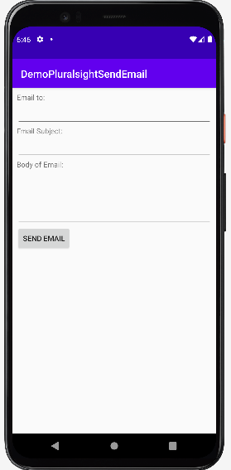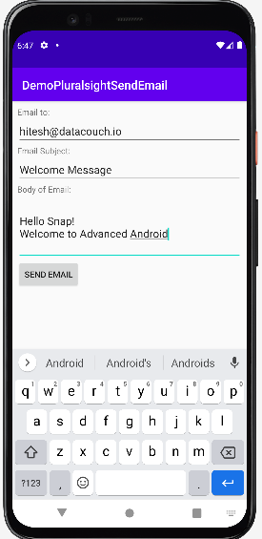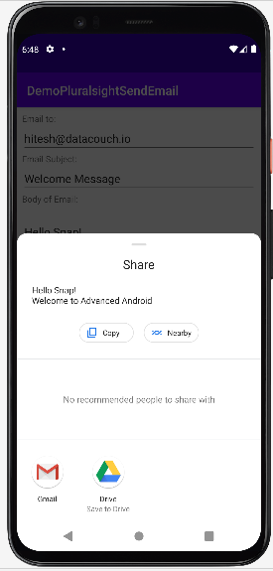

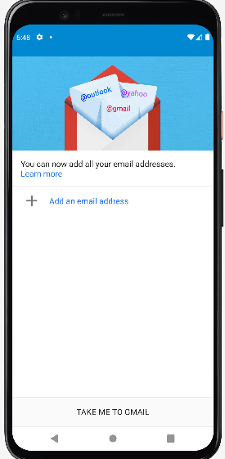

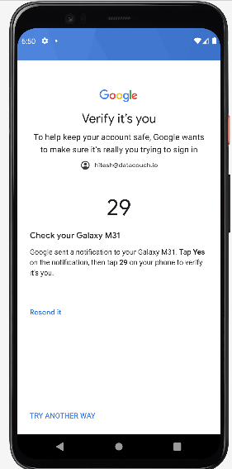

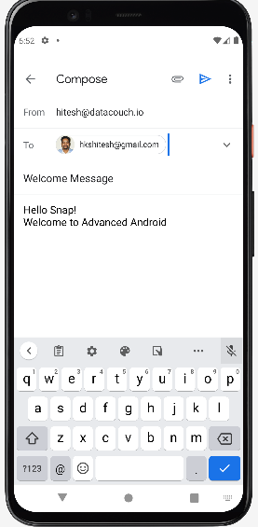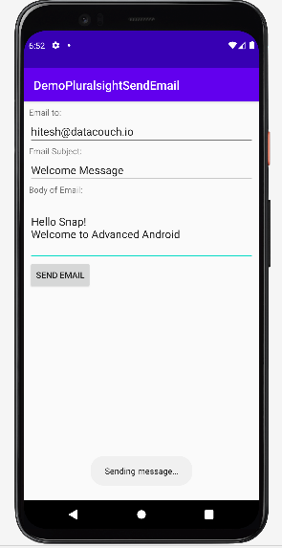

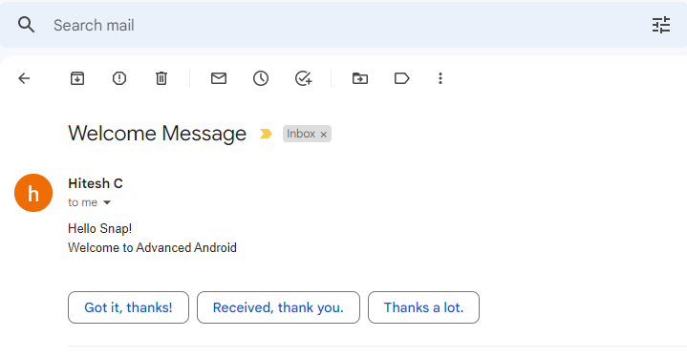

**Voila!!** We have successfully completed this lab.